EHTASHAM AHMED 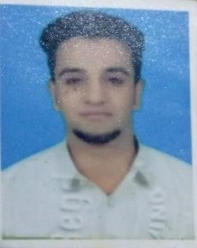

House no CB/541, Street no 13, Muhallah Tali Mori,
Rawalpindi Cantt Pakistan. Cell: +92 333-8968087-051-5513563
Email ID: malikehtasham3245@gmail.com
OBJECTIVE
To build up and enhance my professional capabilities by working in a dynamic organization.
PERSONAL INFORMATION
Name : Ehtasham Ahmed
Father’s Name : Babar Khan
Date of Birth : 19-06-1997
Marital Status : Single
Religion : Islam
Nationality : Pakistani
CNIC No. : 37405-2577154-1
Domicile : Punjab
ACADEMIC QUALIFICATIONS

- Matric | 567/1050 | 2013
- I.Com  EXPERIENCE | 518/1100 | 2017
- 01 years’ work Experience as a Data Entry Operator (Shaheen Chemists) Rawalpindi.
- From 2013 to 2014
- 04 Years’ Experience as a Data Entry Operator (Madina Chemists) Rawalpindi.
- From 2014 to 2017
- 02 Year Experience in Admin Department (MEDASK MH Hospital) Rawalpindi.
- From 2018 to 2020
- 06 Months Experience as a Telephone Operator (Delve Business Network).
- From March to September 2020.
- TDFC Pvt.ltd working as a Assistant Manager and Sales & Marketing Executive.
COMPUTER SKILS
- MS Power Point
- MS Office
- MS Excel
LANGUAGES PROFICIENCY
Spoken languages below:-
English Speaking, Reading, Writing
Urdu Speaking, Reading, Writing

