**M U H A M M A D I J A Z K H A N**

* **Objective**

To work for a reputable organization where I can exhibit my Personal skills and experiences to benefit the organization and grow in the same channel.

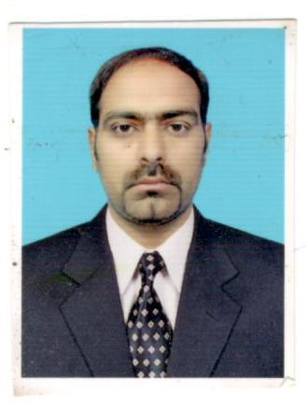

**Personal Information**

Father’s Name :Aslam khan 

Date of Birth : 14-10-1985

Marital status : Single

Nationality : Pakistani

N.I.C : 61101-4424559-1

Email : **ijazkhan149@gmail.com**

Religion : Islam

Permanent Address : VILLAGE PARTAL SHALIMAR CABLES OPPSITE

SULTANAA FOUNDATION (P.O) ALIPURFRASH

ISLAMABAD.

Contact No. : Mob: **03125612536/03455201342**

* **Education**

**M.sc**  : **Physicsfrom Fuuast University ISB**

**M.sed** : Federal College of Education H-9 Islamabad

**B.S.Ed**  : Punjab University Lahore (double math’s& physics)

**Session** : 2008 -2011

**Institute** : Federal College of Education H-9 Islamabad.

**F.Sc**: (Pre-Engineering)from FBISE Islamabad

**Session** : 2007

**Institute** : PCIT Islamabad

**Metric**  : **(Science)**

**Session** : 2003

**Institute** : FBISE Islamabad

* **Courses**

Course : **3 Months course in computer**

Institute : Prince Salman Institute Of Technology Islamabad

Course : **One Month Public Relation Training**

Institute : FDE Islamabad

Course : **One year computer** hardware **and software.**

Session : 2008 – 2009

Institute : **NISTE H-8 ISLAMABAD.**

* **Computer Skills**
* Microsoft Windows 2000 professional. XP2006/98/95/2010.
* Practical Knowledge of Computer Networking and local area Network.
* Maintain troubleshooting of networking cables apply Rj-45 scheme.
* Maintain and installation computer hardware & software.
* Good in Microsoft Word, Excel, PowerPoint, Internet

**Interests and Expertise:**

* + Responsibility towards the accomplishment of assigned tasks.
  + Reading articles and News Papers.
  + Interest in windows based operating systems.
* Good communication skills.
* Ability to work within a team, under pressure and deadlines. Energetic, Professional, Enthusiastic, Self-starter and Creative problem solver who work hard and love a challenge.

* **Languages**
* Urdu
* English
* Punjabi
* Potohari
* Phusto
* Arabic

**Work experience**

* One year in **Paknet Limited** as a office assistant.
* One year in Genentech as Field supervisor different projects( serena hotel, Islamabad airport, Sawat Marble factory Noshehrah and Islamabad)
* **3 years’ Science Teaching experience in IMCB Nilore Islamabad**
* **2 years’ Science Teaching experience in IMSB Khana Naiabadi Isb**
* **1 year student coordinator/Admin officer experience in FCE H-9 Islamabad**

## **Document Controller at Tasees al Mubani General Construction Company pvt MADINA KSA.**

* **Responsibilities, Duties and Tasks performed**
* 1) Responsible for understanding of the work-flow the information-flow
* 2) Check the work of other document control employees/contractors for making sure consistency and conformance with Company standards, policies practices
* 3) Interface with project management staff to ascertain schedule of deliverables, distribution lists - matrices - for projects
* 4) Provide data for progress reporting including percent complete, earned value other schedule/status reporting
* 5) Maintain organize files of - controlled - documents, including incoming outgoing transmittals
* 6) Maintain tracking database of - controlled - documents
* 7) Interface with staff, vendors clients to make sure timely delivery of scheduled deliverables
* 8) Meet deadlines prescribed by staff, clients, and vendor’s delivery requirements
* 9) Check all work for compliance to the project plan, Company policies/procedures database conventions/standards
* 10) Balance requirements of multiple projects at various stages of completion
* 11) Prioritize work assignments of self-others
* 12) Schedule work of self to document, distribute, file and report on - controlled - documents to meet internal external deadlines
* 13) Follow established Company and department guidelines and practices to include consistent use of filing documentation conventions

* **Reference**

Will be furnished on demand.