ALI HAIDER.

New miana pura near nana chowk 51310,

SIALKOT, PAKISTAN

Father name: | MUHAMMAD SALEEM
Email address: | Info.haiderali123@gmail.com
Nationality: | Pakistani
Domicile: | Sialkot/Punjab
Marital Status: | Single
CNIC Number: | 34603-0581070-3
Religion: | Islam
Contact: | +92 305-6007932
Passport No: | EB6970701
Date of Birth | 06-11-1998
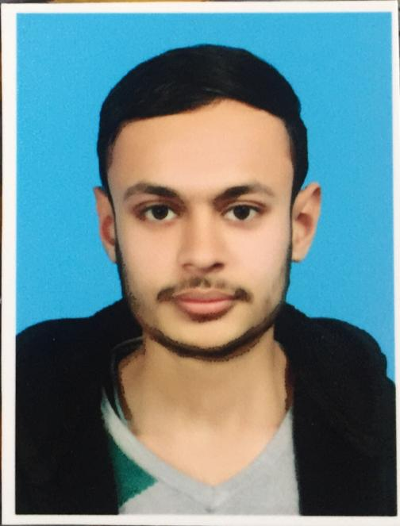

Career Objective
To make use of my professional skill and abilities in commercial and domestic refrigeration air condition technologies working in dynamic organization for business growth.
To excel among the professionals. Where I can utilize my skills with strong commitment
And dedication, for the progressive growth of the company.

Skill
- Refrigeration Air conditioner & Electration.
- Excellent Language Skills.
- Good communication Skill.
- Sincerity toward job and punctuality.
- Able to cope under pressure.

Middle.
Govt. high School kotli Bahram Sialkot.
Education
Diploma.
Refrigeration and Air Conditioning 14 month (Punjab Vocational Training Council, Sialkot)

Professional Experience
- 2 year Experience in Refrigeration Air conditioner & Electration.
- One Year Experience self-work on market.
- Two year Worked as at “Mehboob Electronic & Cool way”

Interpersonal Skill
- Highly Developed interpersonal Skills with an ability to work with multicultural and multidisciplinary teams.
- Good Analytical and problem-solving skills.
- Self-confident and Hardworking nature.
- Ability to work both independently and as a team player.
Reference
Will be furnished on demand.

