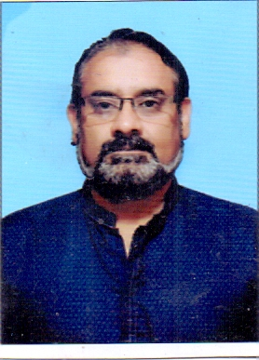
C.V of Kamran Anwar Ghouri

Objective

“ To seek a career job where I contribute towards the growth and the development of the dynamic organization that offers challenging opportunity and appreciate the performance criterion.”
Personal Information

Name Kamran Anwar Ghouri

S/O Muhammad Anwar Ghouri
Marital status Married
Religion Islam
Nationality Pakistani
NIC # 35201-5548424-5
Present/postal Address Lalzar Colony, Tulsa Road, Rawalpindi.

Skype ID jukeedada
Mobile 0336-9321658
0311-5938830
Email Address: jukeedada@hotmail.com
faisalboyswing@gmail.com
Interested to teach Economics, Statistics, and Mathematics

Achievements Worked as Subject Head (Science) from Class Ist to Class 8th.
Worked as Subject Specialist Maths for Elementary/Secondary Classes.
Worked as Academics Head
Worked as E-Learning Incharge.
Worked as Syllabus Designer for the year.
Have worked on Lesson Planning (Daily, Weekly and term wise)
100% Matric Result with A+ Grade.
Have trained teachers successfully.
Management Skills
Experience
Vice Principal Scienta Vision College (Islamabad)
01 January 2019 to date
Principal Faisal Model High School ( Position Holder School in Matric Examination in Rawalpindi Board)
07 April 2014 to 30 December 2018
Principal Allied School, Project of Punjab Group of Colleges
10/August/2011 to April 2014
Vice Principal Professional Institute of Commerce & Sciences
10 June 2009, to June 2011.

Section Head/Sub. Specialist Latif Foundation School Rawalpindi,
10/April/2007 to 15/May/2009

Subject Specialist (Maths/Comp) Bab-ul-ilam evening College, Garhi Shahu Lahore,
College Section1 0/January/2005 to 10/January/2007
Subject Specialist (Maths/Comp) National Textile College of Management Sciences, Lahore
College Section 10 January 2001 to 31 December 2004.
Volunteer Experience Govt. Iqbal Hussain Community College, Lahore.
Education Master in Computer Sciences.
M.A (Education)
B.Ed
Bachelor in Computer Sciences
B.A
F.A. with Mathematics & Statistics
Matriculation with Science
Computer Courses Ms-Word, Ms-Excel, Ms-Power point, Windows XP
Professional Education Member of Institute of Chartered Accountant of Pakistan
Member of Society of Actuaries USA
Key Skills
Strong Communications Skills.
Adaptability to adjust in new social and work environment.
Strong follow up skills.
Responsible and professional attitude.
Strong teaching Skills.

