Waqas Khan
Add: Bhattari, P.O. Rehana, Teshil & District Haripur.
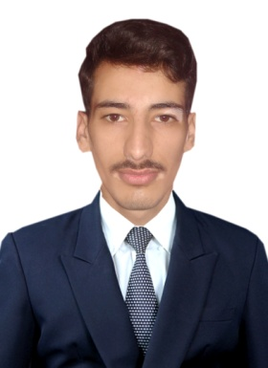
Voice: 0342-5294386
Objective:

I believe in hard work and very confident about myself to become a part of
well reputed organization and show my abilities there and play my role in its progress.
Personal Details:

- Father’s Name Muhammad Nawaz
- Date of Birth 5th May 1998
- CNIC No 13302-2819495-3
- Religion Islam
- Domicile Haripur (K.P.)
- Marital status Single
- Nationality Pakistani
Education:

Certificate | Marks/Grade | Session | Board
Matriculate (Science) | 733/1100 | 2014 | BISE Abbottabad
F.Sc. (Pre-Engg)  (Equivalency Certificate) | - | - | IBCC Islamabad
D.A.E. (Civil) | 2483/3450 | 2017 | BTE Peshawar

Experience:

- 1 Year 2 Months worked as a Laboratory Technician in ZKB Motorway Project, Haripur.
- 3 Months Internship Trainee as a Sub-Engineer Helper in C&W, Haripur, K.P.

Languages:

- English, Urdu & Hindko

