CURRICULUM VITAE

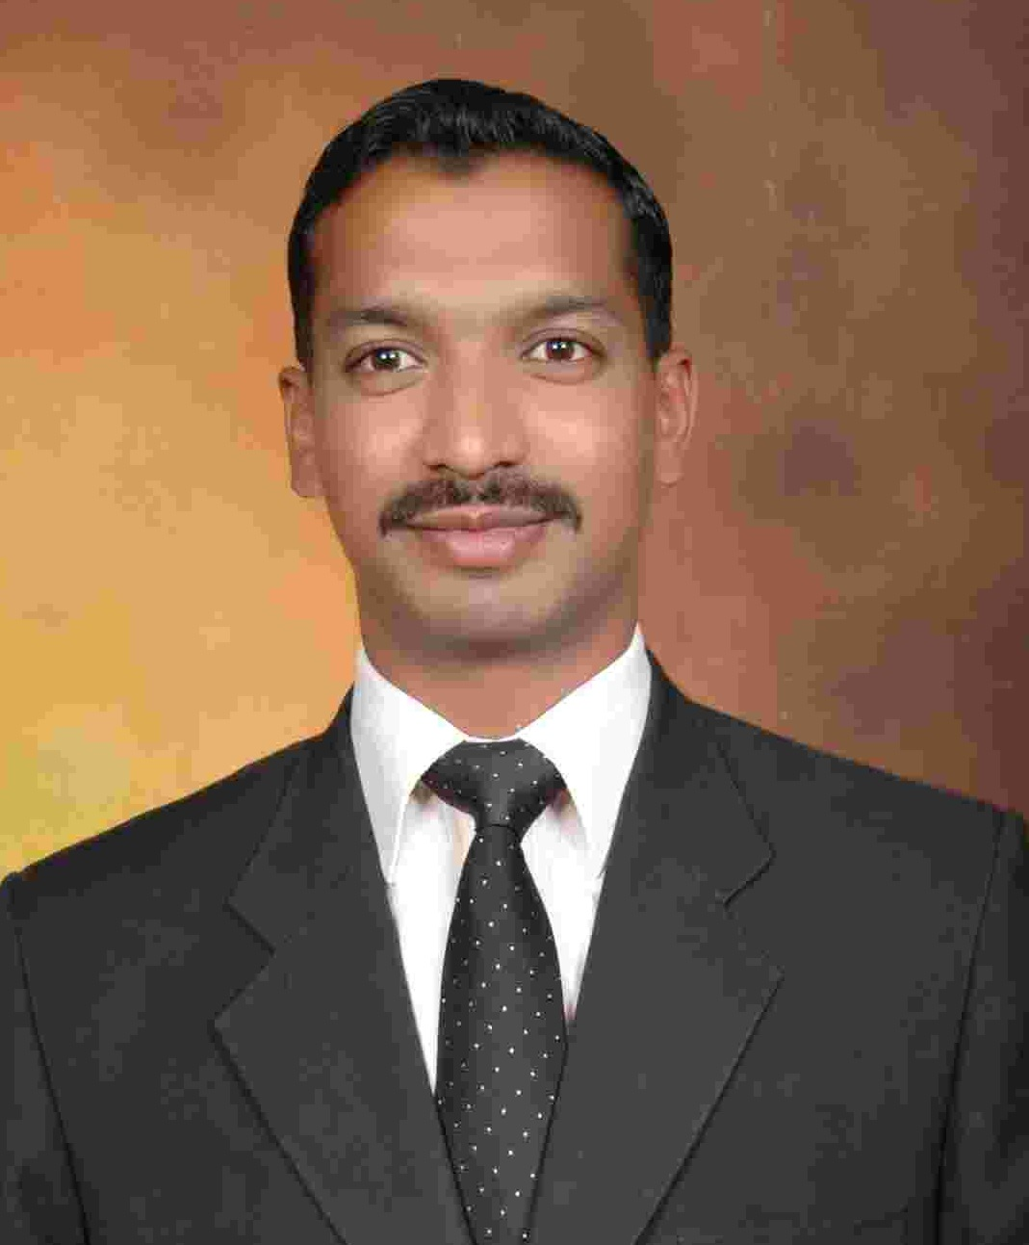
OBJECTIVE: To realize my true potential by working in an environment
Which conductive to handwork and creative thinking to seek a responsible,
Challenging and rewarding position with a leading organization that ensure
Long term carrier development and growth opportunities.
PERSONAL INFORMATION:

Name AZMAT ALI
Father name MUBARAK ALI
Nic 37405-0834173-3
Sex Male
Date of birth 11-August-1985
Marital status INRELATION
Nationality Pakistani
PASSPORT NO GB 1791733
Email aliwaris5304663@gmail.com
CELL 0092-332-3404400
ADDRESS H#ZB 2596 ST#03 NAWAB COLONY DHOKE HASSU RAWALPINDI PAKISTAN
Skype ID aliwaris5304663@gmail.com

QUALIFICATION:

MATRIC (SCIENCE) Federal Government School Cantt Rawalpindi
DAE ASSOCIATE IT ENGINEER KRl (Atomic Energy) Institute Of Abdul Qadeer Khan
Research Laboratory Kahota.
BA AIOU University Islamabad.
LLB=MA Punjab University Lahore.

EXPERIENCE OF UAE AND PAKISTAN.
3 YEARS IN RESCUE DEPARTMENT AS Coordinator and
5 YEARS EXPERIENCE IN FEDERAL PUBLIC KASHIF MODEL HIGH SCHOOL (KMS) AS PRIMARY AND SECONDARY CLASS TEACHER
4 YEARS AS A senior class Teacher and subject teacher OF ENGLISH ,
URDU,
BIOLOGY,
COMPUTER
,ISLAMIYAT,
PAKSTUDIES
INTERNATIONAL LAW
CIVIL LAW
PUBLIC LAW
ISLAMIC JURISPRODENSIA
ENGLISH JURISPRODENCE.

WORK AND EXPERIENCE IN PAKISTAN
RESCUE 1122 PUNJAB EMERGENCY SERVICES 2006-TO -2009.
As a Coordinator. POST CTWO.

CERTIFICATE BY JAPAN RADIO COMPANY (J R C) JAPAN THROUGH RESCUE1122.
As A Coordinator. I worked with Japan (JICA) Company in Japan five months

CERTIFICATES.
(OGDCL) pvt limited Head Quarter Islamabad.
Certificates of Fire and Safety officer Course from NIFT CIVIL DEFENCE DIRECTOTRATE ISLAMABAD

CERTIFICATES SPECIAL IZATION COURSES
- Dispenser/Nursing Assistant
- Fire prevention and safety officer course for industries from (DGCD) directorate general civil Defense national institute of fire technology (NIFT)
- Fire prevention and safety officer course for educational institution from (DGCD) directorate general civil Defense national institute of fire technology (NIFT)
- Fire prevention and safety officer course for oil installation from (DGCD) directorate general civil Defense national institute of fire technology (NIFT)
- Fire prevention and safety officer course from Pakistan Railways Carriage Factory.

WORK AND EXPERIENCE IN PAKISTAN
RESCUE 1122 PUNJAB EMERGENCY SERVICES TRAINING 8 MONTHS OF FIRE PREVENTION AND SAFETY COURSE ALSO FIRST AID IN EMERGENCY.
RESCUE 1122 PUNJAB EMERGENCY SERVICES 2006-TO -2009.

COMMUNICATIVE SKILLS
Extra ordinary ability to act as Team Tember and Friend
Excellent communication skills in spoken written and oral
Special in English certificate from (UCAT) IELETS and Arabic

SPECIAL
- ITAnalyst microprocessor
- Visual basic language (VB)
- Hyper text markup language (HTML) ---
- Turbo c (Tc,c+,c++)
- Telecommunication,
- Occupational Health and Safety Environment (OHSE).
- CCTV SURVILLIANCE OPERATOR

COMPUTER SKILLS
- Operating system
- E.com
- Pc system architecture
- Operating system
- Ms-office word/ms excel /ms power point

LANGUAGE SKILLS
ENGLISH
ARABIC
URDU
PUNJABI

COORDINATOR EXPERIENCE IN ABUDAHBI (UAE)
Coordinator in Etihad Gulf Airlines (Etihad Airways) Airports.
Coordinator in Supervision Committee of Abudhabi International Airport (SCADIA)
Coordinator in ADCB (Abudhabi Commercial Bank) Head Quarter.
AS A Coordinator I GOT EXECLENT EXPERIENCE AND I HAVE 4 YEARS OF Coordinator EXPERIENCE OF UAE IN SECURI MIDDLE EAST COMPANY

COORDINATOR EXPERIENCE
AS A Coordinator I GOT EXECLENT EXPERIENCE AND I HAVE 4 YEARS OF Coordinator EXPERIENCE OF UAE IN SECURI MIDDLE EAST COMPANY.AND 3 YEARS IN RESCUE DEPARTMENT AS Coordinator and
5 YEARS TEACHING EXPERIENCE IN FEDERAL PUBLIC KASHIF MODEL HIGH SCHOOL (KMS) AS CLASS TEACHER OF SENIOUR AND JUNIOUR CLASSES.

************AIM TO GET MY TRUE DREAM INSHALLAH*******

