Mr. Saileen Khan chemist. | 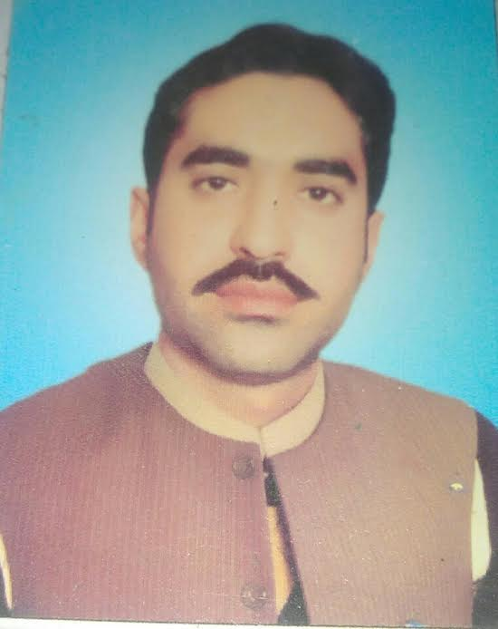

Cell #: 03364375760

E-mail: khansaileen7@gmail.com
Aims & Objectives

To become part of a dynamic group of people where I could utilize my skills potentials for the betterment of Organization.
Personal Profile
Father’s Name: Misal Khan
NIC No: 16101-8705110-9
Marital Status: Married
Religion: Islam
Nationality: Pakistani
Birth 25th dec 1988
Address: Kot Daulat zai Garhi kapura Mardan

Qualification
DEGREE | SUBJECT | YEAR | Grade/Division
M.sc | CHEMISTRY | 2011 | 1st
B.Sc | CHEMISTRY, ZOOLOGY, BOTANY | 2009 | 1st
HSSC | Pre- Medical | 2007 | 1st
SSC | Science | 2005 | 1st

Professional Experience

Presently, I teach chemistry at FWO Institute of Technical Education Risalpur Cantt on contract basis as an Instructor from Aug 20^{th,} 2015 to till date.
5 years and three months teaching experience as a chemistry lecturer at National foundation of resource development (NFRD) Rawat Islamabad..
Proffesional Qualification

- B.Ed with 1st division ….
References

References will be provided on demand.

