**A little about me:**

Myself “Basit Ashraf” a computer science graduate (Gold Medalist) from “Abbottabad University of Science and Technology Pakistan”.

I have hands on experience with “Android Development” and also have “online teaching”

Experience of about 1 year of teaching different technological subjects like Android Development, Illustrator. I am very good in problem solving and time management. I love to be a part of some growing organization where I show case my talent.Some of my work is as below.

**Experience:**

* Android developer at TechValley Abbottabad
* Android developer at TechCamp Abbottabad
* Trainer at Online Business Hub

**Android Development:**

**1:TechValley Conference:**

**Link: <https://play.google.com/store/apps/details?id=com.umer.sohailsadiq.newtvc18>**

**2:Hajj Guide:**

**Screenshots:**

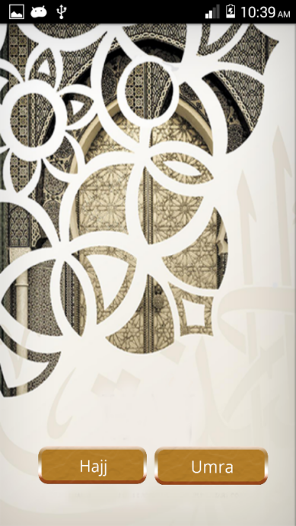

**3: Opportunities Alert using fragments like this**

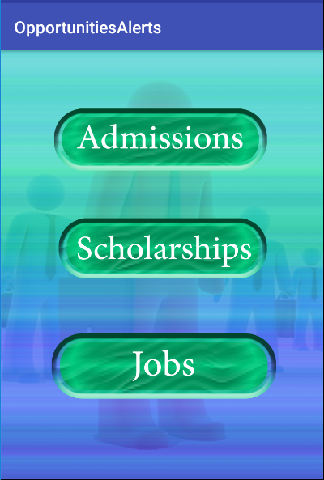

**4 : N-Queens Game**

**Screen shots:**

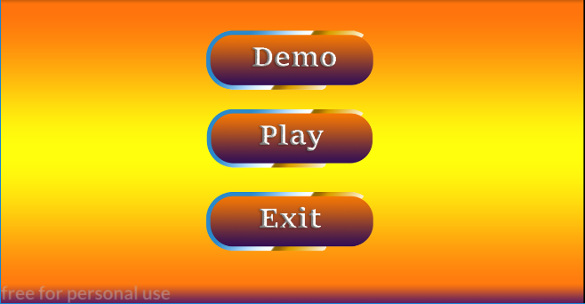

**Typing Expert:**

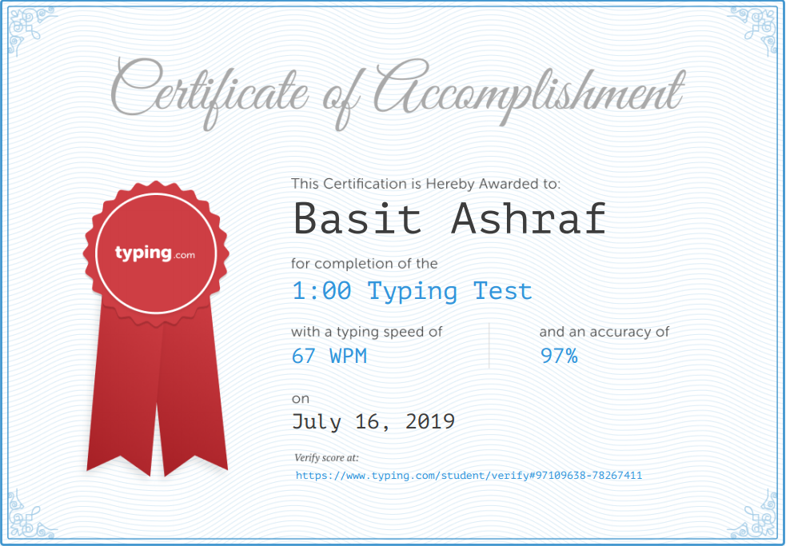

**Teaching:**

I am working as a lead trainer at Online Business Hub Islamabad Pakistan. I teach technical subjects like Android development, Illustrator, photo-shop, database, operating systems etc.