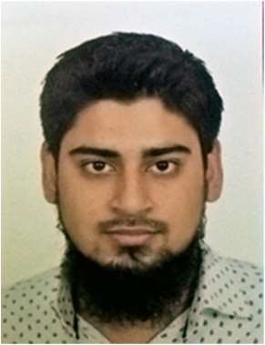  CAREER OBJECTIVES  A fresh graduate in chemical engineering who wants to join an organization where my knowledge of chemical engineering can be best utilized and where I can get good career growth, both intellectually and financially.  Available from 1st December 2019.  Contact  PHONE:  +601136643400  EMAIL:  muzammil25@live.com  ADDRESS:  Pantai Hillpark Phase 5, Bangsar South, Kuala Lumpur  Hobbies  Reading  Sports  Socializing  Computer  Travelling  SKILLS |  | SYED MUZAMMIL IQBAL  EDUCATION  Bachelor’s in chemical engineering  University of Malaya (UM)- Kuala Lumpur  2013 – 2019  Attended a full-time student in Engineering Studies Department and earned a bachelor’s degree in the field of Chemical Engineering.  • CGPA (2.96)  GCE A-Levels (Cambridge International Examinations)  Beaconhouse School System- Karachi, Pakistan  2011 - 2013  • 4 GCEs grades A - B, including Math, Biology, Chemistry and Physics  WORK EXPERIENCE  3Phase Reservoir Technology Sdn Bhd - [Intern]  July 2019–September 2019  • As an intern, assisted and performed different tests related to oil sampling and analysis including flash liberation test, bubble point determination and pour point test.  • Developed communication and teamwork skills required at professional level.  Conservative Volunteer - University of Malaya  • Leaded a team of six people to improve green spaces in local areas; with the aim of reconnecting people and the community with nature.  PROJECTS  Research Project – (Iterative Learning Control in Fed-Batch Fermentation Process)  • Developed Iterative learning algorithm to optimize fed-batch fermentation process.  Design Project – (Production of Dimer Acid from Palm Kernel Oil)  • Worked in a group to design Dimer acid production plant including technical and economic feasibility, process flow diagram and P&ID.  Cultural Entrepreneurship Project  • Worked as a group to develop business plan and skills to manage and run a business stall.

