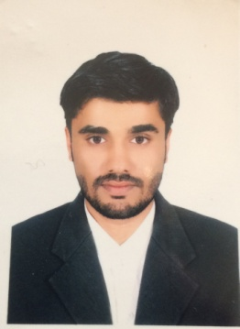
Resume

Muhammad HAROON
Address: House No.1996/B Mohallah Chowk Sadiqia Dera Ismail Khan

Mob#0348-9662148

OBJECTIVES

I want to show the best of my skills and efforts, and have also a chance to improve my knowledge/ skills. I will prove myself as an asset for the betterment and growth of organization concern.

PERSONAL BIO DATA

- Father’s Name : FAZAL-UR-REHMAN
- Date of Birth : 05/08/1996
- C.N.I.C # : 12101-7804381-9
- Domicile : D.I.Khan (KPK)
- Nationality : Pakistani
- Religion : Islam
- Marital Status : Single
- Email : haroonkhan12101@gmail.com

ACADEMICQUALIFICATION

EXAM | YEAR | Marks | BOARD /UNIVERSITY
S.S.C | 2013 | 631/1050 | B.I.S.E D.I.Khan
D.A.E Electrical | 2016 | 2331/3550 | Technical Board Of Peshawar

- EXPERIENCE
- 01 Year experience in L.T and H.T lines and basic wiring.
- 02 Years experience in Pak land Electronics workshop as an Electrical Technician.
- 02 Years Experience of Generator Works as an Electrical Technician.
- 01 Year Experience in Chashma Sugar Mill as a Electrical Technician.
- RESPONSIBILITIES
- Installing, Assembling and Repairing of the Basic wiring, Solar system, UPS and Generators.
- Installing and repairing of single Phase, Three Phase AC Motors, and Step up and Step down transformers.
- Mantenance of electric turbines and electric power pumps.

