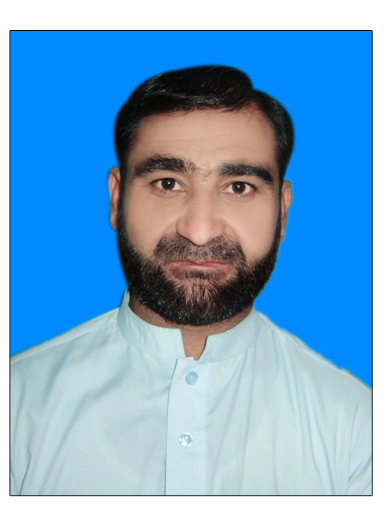
Manzoor Ahmad
Present Address:
House # 207, Street-12, Sector L-2, Phase3
Hayatabad Peshawar, Pakistan
Cell: 0092332-9797174, 0092343-9828976
E-mail:manzoor.raaz@gmail.com
E-mail:manzoor_raaz@yahoo.com
Skype ID: manzoor_raaz
Date of Birth: 4 April 1988

PEC Registration Number
ELECT/51992

Objective

Seeking a challenging Career in the fields related to Power and Communication Engineering and to achieve professional excellence and distinction through sheer proficiency & team effort to attend personal ideas, objectives and company goals.

Employment History
- Hitech Network Pvt Ltd Pakistan 1 June 2014– To till Date

Ufone Core Location P&I Engineer
Currently working (TL/Coordinator) O&M Operations North-2 in Hitech (PTML Ufone Project) with major responsibilities as follows
- Fire Systems panel and detectors also doing Supervision in Ufone MGW Peshawar Power Field as well, so I have knowledge and experience on fire system as well
- Currently working and managing PM and CM of DG and AC PTML Ufone MSC Core Location and Customer Service Center Offices
- MOR Installation (Manual Operation system and interlocking of ACBs Air Circuit Breakers )
- Electrical Panel & DBs Installation and maintenance
- Ufone MSC 630 Kva DG, Ufone Customer Care Offices 65kva and 165 Kva DG and 2 , 4 Ton ACs Maintenance , also managing Opex Report
- Maintaining management reports daily, weekly and monthly
- Operate and manage (Teams, vehicles and their issues on daily bases) to achieve KPIs.
- To check, investigate and report to management about (hazards / incidents/risk analysis) and to create awareness in teams about SOPs.
- Execute PM and CM on access network ERP Software and ensure that they are executed in accordance to SOP.
- Monitoring and controlling Regional Opex as per assigned budget
- Implement cost reduction strategies for fuel Opex, DG maintenance Opex.
- Directs coordination efforts with Back Office, Field Maintenance, Customer Service and other Teams regarding network concerns.
- Assist Manager in preparing Major Incident Report.
- To conduct necessary preventive and corrective maintenance and their audits with reference to Sites
- Lead the implementation of technical project and act as project lead point of contact to internal and external organizations.
- Responsible for planning & executing PMs (Preventive maintenance Schedule), M/R (material requirement) for both P.M and C.M (corrective maintenance) on monthly basis
- Responsible for managing teams to execute daily based planned tasks.
- Responsible for maintaining engines records, feedback from field teams, on daily basis and then finally sharing with Senior Project Manager.
- Responsible for arranging emergency power source in case of prolong engine fault.
- Installation, operation and commissioning ATS & AMF panels and Air cons.
- Responsible for maintaining Gensets functioning automatically.
- To troubleshoot and rectify non-Telco related issues.

- Trainee Engineer (AGES Consultant) 25 October 2012 -1 June 2013

Trainee Engineer with ages consultant and major rules as fallows
- After Civil Work of Buildings, Homes Colony and Power House electrification designing of installation wiring of lights,fans,ACs, Cameras , Detectors and transformers
- To find the size of using cable in installation
- To find the breaker rating for installation after calculation of full load
- Earthing

- Personal Workshop Work 2 May 2013– Present Till Date
- Making New Ups 1000watt ,2400watt of 12V and 24V
- Troubleshooting and repairing of Ups
- Installation and wiring of Ups In homes and buildings.
- Internet Cafe 1May 2010 – june 2012
In student period have done part time job in internet café and mentioned below
- Work as a operator in internet café to handle the complaints of customers and noting the users internet sitting hours and troubleshooting of computer systems and internet complaints.

Academic Qualifications
Degree Institute Divison Year
BE Electrical(Power) | Sarhad University of Science and Information Technology Peshawar | 2nd | 2014
FSC (Pre Engineering) | Warsak Model School and College Peshawar | 2nd | 2007
Metric | Hangu Public School and College Hangu | 2nd | 2004

Computer and Software Tools
- ERP Software company Software Experience (Procurement Software)
- Completed course PLC (NIDA, National Institute of Design and Analysis).
- I-manager M2000
- AutoCAD Electrical Designing (AGES Consultant)
- UPS Repairing & Troubleshooting
- MS Office
- O&M and Company invoice and budget ERP Software
- Installation and Maintenance of Laptop OS (WinXP, Win7), Downloading various tools for technical softwares, keeping an updated antivirus to prevent from viruses.
- Spreadsheets (Microsoft Excel), Word Processors (Microsoft Word), Presentations (Microsoft Power Point) and various Communications Programs.
- Excel Reporting

References
Haji Muhammad
Regional Manager Engineer (Huawei N-2)
Mob 0335-5500042

