

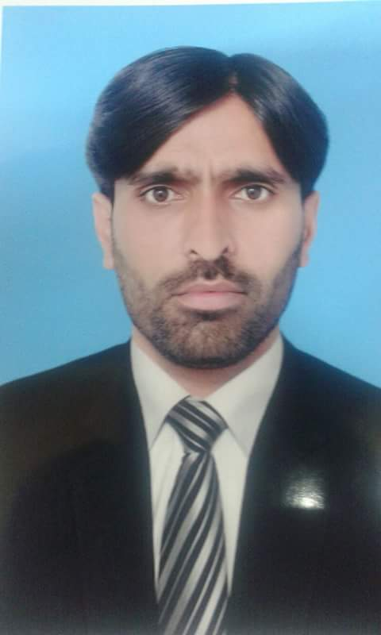

|  |
| --- |
| **MUHAMMAD RIZWAN KHAN** |

|  |
| --- |
| **Personal Profile** |

Father name: Muhammad Akram

Date of Birth: 18th February 1985

NIC No: 37405-6606779-1

Language: English, Urdu, Punjabi

Marital Status: Single

Nationality: Pakistani

Domicile: Punjab

Religion: Islam

|  |
| --- |
| **Contact Information** |

Address: House # 13, Street # 5, Bankers Colony, Defence Road, Rawalpindi, Pakistan

Mob: (+92) 0320-504 0106, 0315-504 0106

Email Add: nakralian@gmail.com

|  |
| --- |
| **Education Description** |

* **Masters _ MSc. (Maths)**
* **Masters  MBA (Finance) 3.5 Years**
* **Masters _ Education**
* **Association of Chartered Certified Accountants (ACCA) Partly Qualified**
* **Bachelor  Bachlor of Education**
* **Bachelors  Bachelor of Science**
* **Intermediate  Pre Engineering**
* **Matriculation - Science**

|  |
| --- |
| **Experiences** |

* **Senior Elementary School Educator (Maths) 2012 to date**
* **District Teacher Educator (Master Trainer) 2015 to 2017**
* **Elementary School Educator (Maths) 3 Years**
* **Accounts/ Admin Manage 2 Years.**

Aitech Engineering Company Pakistan. *(*[*Invoice Discounting*](http://www.rozee.pk/search/invoice-discounting-jobs-in-pakistan)*,*[*Bookkeeping*](http://www.rozee.pk/search/bookkeeping-jobs-in-pakistan)*,*[*Voucher Management*](http://www.rozee.pk/search/voucher-management-jobs-in-pakistan)*,*[*Sales Audit*](http://www.rozee.pk/search/sales-audit-jobs-in-pakistan)*, Petty Cash Management***)**

|  |
| --- |
| **Computer knowledge** |

* **5 Years experience of MS Excel**
* **01 year Diploma of information technology**
* **08 weeks Computer Course For Graphics / Web Designing**
* **Quick Books Accounting software**