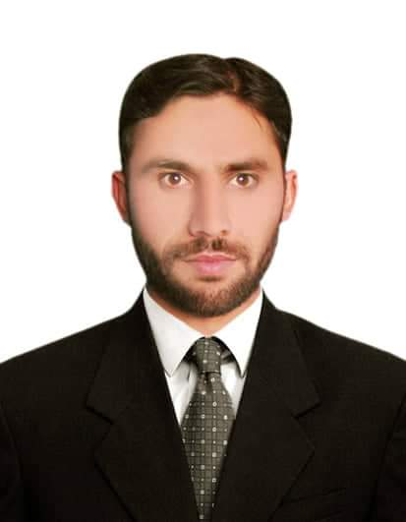
LUQMAN HAKEEM
Personal Information
Father Name | Pehlawan Khan
Date of Birth | 07-05-1992
Nationality | Pakistani
Passport no | Al 6350081.
Postal Address | Omaya binte abdl motalib binte Hashem street Alarayasah Najran saudi arabia.
Email Address | Email (1) |  | Email(2)
Email Address | drluqmanafridi46@gmail.com |  | Hakeemluqman897@gmail.com
Telephone No. | Landline (Home/Office) | Mobile |  | Mobile
Telephone No. | Contact & WhatsApp +966 | 582386361 |  | 591961789

Education Qualification
Years |  | Degree/ Certificate Name | Field of Study/ Major Subjects | Institution/Board/university | Grades/Division
From | To
2012 | 2016 | BS Degree | BSs (hons) Dental clinical technology | Bacha Khan University Charsadda , Pakistan. | CGBA 3.18
2010 | 2012 | FSc | Medical technology Dental Hygiene | B.I.S.E Peshawar, Pakistan | 57 Percentage
2007 | 2008 | Ssc | Biology | B.I.S.E PESHAWAR Pakistan | 61 Percentage

Trainings Relevant to the Job
Years  (DD/MM/YYYY) |  | Place  City/ Country | Topic/ Title of Training | Institutions
From | To | Place  City/ Country | Topic/ Title of Training | Institutions
2018 | 2019 | Peshawar Pakistan | Oprative Dentistry Dental Surgery Endodontic | Private clinical experience
2017 | 2018 | Peshawar Pakistan | Oprative Dentistry Dental Surgery Endodontic. | Private clinical experience
2016 | 2017 | Peshawar Pakistan | Internship at operative dentistry dental surgery  Endodontic departments | District Head Quarter Hospital Landi Kotal Khyber
2011 | 2012 | Peshawar Pakistan | Deptt of dental Hygienist | Nasir ullah babarl Hospital Babar Memorial Hospital
2010 | 20111 | Peshawar Pakistan. | Deptt of dental hygienist | Nasir ullah Babar hospital

Language Skills

( Basic / working knowledge / fluent )
Language | Read | Write | Speak | Understand
Pashto | fluent | Fluent | fluent | Fluent
Urdu | fluent | Fluent | fluent | Fluent
English | fluent | Fluent | fluent | Fluent

RESEARCHES:
1. BS hons Dental Technology .
Research Topic : Dental Anxiety Among Patient and Dentist.
INTER PERSONAL SKILLS:
a) Have the passion to conquer new grounds
b) Excellent communication skills
c) Sound analytical approach
d) Robustly goal oriented
e) Strong mental approach

REFERENCES:
Will be provided on demand

