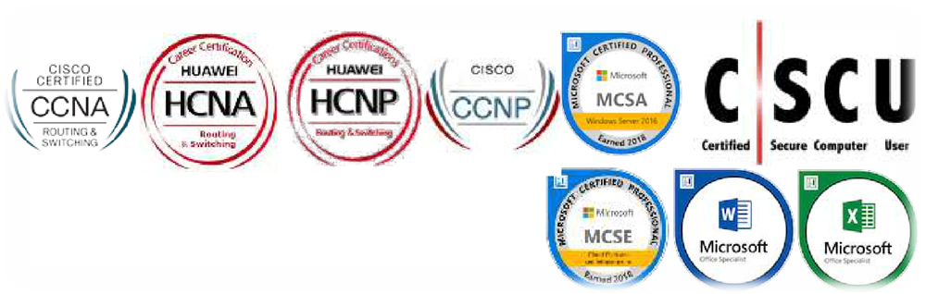

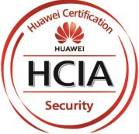

Curriculum Vitae

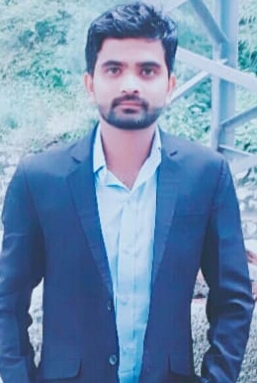

GHOHIR RIAZ
House # Gujjar town village kaleke Mandi District , Hafizabad
Contact No: +92 3060743885
Email Address: goharriaz516@gmail.com

SUMMARY
I have done my Bachelor of science in computer science BS(CS) from University of South Asia Hec Recognized University.I am MCP,MCSA,MCSE Server 2016 ,CCNA(R&S),CCNA(Security),CCNP,
HCIA(R&S),HCIA (SECURITY),HCIP(R&S),Cyber Security and Cyber Essential Certified from Cisco ,Microsoft And Huawei. I am responsible for providing support to corporate customers regarding different services. I am a practically oriented and a willing team player, who readily accepts new challenges and strives to make the difference in the place of my work. My colleagues know me as a trustworthy person, who delivers on commitments. I have an ambition to grow and excel in my career.

PROFESSIONAL EXPERIENCE:
My total experience In IT field is (April,2018 - April,2019)
Job Responsibility:
- Computer Incharge and Coordinator
- Network Engineer
- Assembling the Computers.
- Configuration of the Computers with the internet.
- Solving the regular upcoming Hardware issues.
- Evaluating the network issues.
- Solving the technical issues of the employees.
- – Complete understanding of computer hardware
– Complete technical understanding and use of software
– Knowledge of printer and cartridge refilling
– Knowledge of digital and analog embedded computer hardware
– Experience with applications and programing
– Experience installing software and applications to a personal standard
– Trouble shooting of personal computers and on-line support to customers with
- Management and maintenance of servers, pc’s, routers and switches
– Experience managing network security tools
– Experience managing firewalls, anti-virus and intrusion detection systems
– Identifying network performance issues
– Configuration of network equipment’s
– Managing and maintenance of network equipment’s
– Troubleshooting, solving and documenting network connectivity issues
– Installing an configuring workstations

CERTIFICATIONS:

Cisco And Huawei Certifications:
- CCNA R&S Certified 2019
- CCNA Security Certified 2019
- HCIA R&S Certified 2019
- HCIP R&S Certified 2019
- HCIA (SECURITY) Certified 2019

Microsoft Certifications:
- MCP (Microsoft Certified Professional) Certified 2018
- MCSA (Microsoft Certified Solution Associate) Certified 2018
- MCSE (Microsoft Certified Solution Expert) Certified 2018

Programming certifications:
- WEB DESIGNING (TEVTA) Certified
- WEB DEVELOPMENT (APTECH COMPUTER EDUCATION ) Certified

OFFICE Certification:
- Microsoft Office (2007,2016)
- English Language Certification
- Cyber Security Certified
- Cyber Essential Certified

Trainings:

- Graphic Designing
- CCNP
- Certified Secure Computer User v2
- MS Office (Word ,Excel ,Power point)
- Typing speed 45+

SKILLS:

- Must be able to use GNS3.
- Must be able to use packet Tracer.
- LAN,WAN AND MAN experience.
- Tcp/Ip , Security, Routing, HTTP/HTTPS, Load balancing ,UDP,DHCP,DNS.
- L2 Switch,L3 Switch, Subnetting,Rip,Eigrp.
- Knowledge of IP addressing, Switching, Routing protocols (OSPF, BGP) and MPLS.
- Configuration, Maintenance and Troubleshooting of IP Network nodes
- Diagnose and locate circuit, component and equipment faults; Complete work orders, test and maintenance reports; Maintain, troubleshoot and administer the use of local area networks (LANs), wide area networks (WANs), mainframe networks and computer workstations and peripheral equipment.
- Active Directory, Web Proxy, FTP
- installing and configuring computer networks and systems
- identifying and solving any problems that arise with computer networks and systems.

EDUCATION:

- BS(Computer Science) University of South Asia 2018

Interest And Hobbies:

- Playing board games and Solving all kinds of puzzles.
- I love learning new languages.
- Communicate well and connect with others.

Languages:

- Urdu
- English

