H M Toseef

Address: Begumpura Near UET Lahore. Pakistan.
Mobile, Whatsapp, IMO: 0092-323-4667834

E-Mail ADDRESS: toseef834@gmail.com , toseef834@yahoo.com

PERSONAL PROFILE
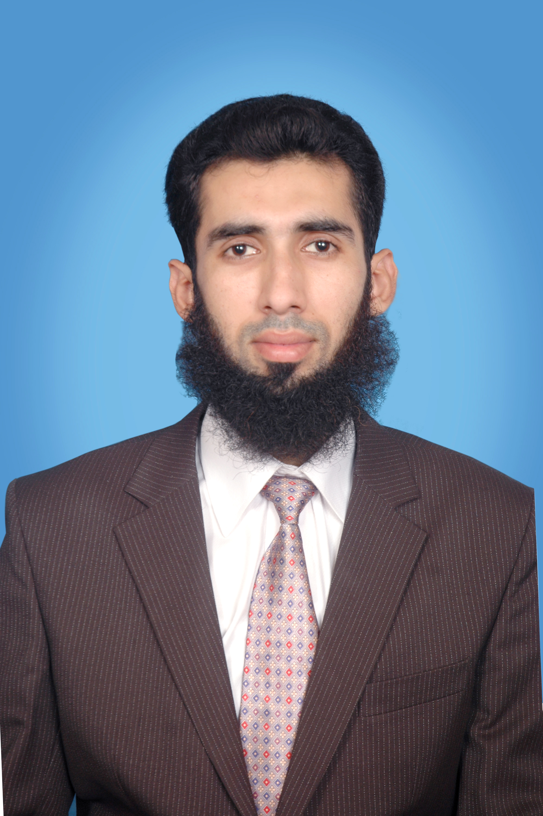
FATHAR’S NAME : Muhammad Aslam
DATE OF BIRTH : 31st October 1988
RELIGION : ISLAM
Passport # : AB7882361
CNIC # : 35201-8025236-5
MARITAL STATUS : Married
Driving License No. : LE-17-36672
Iqama Number : 2422144143

ACADEMIC QUALIFICATIONS
Degree | Subjects | Year | Division/grade | Institution
M.Phil | Applied Mathematics | 2014-16 | CGPA 3.125 out of 4  Equivalent to 76% | University of Engineering & Technology, Lahore
M.Sc | Mathematics | 2012 | 1st Division  Mathematics 68% | University of Engineering & Technology, Lahore
B.Sc | Math A & B,  Physics | 2010 | 1st Division  Math 66% | Punjab University
F.Sc. | Pre-Engineering | 2007 | 1st Division  Math 69% | BISE Lahore
Matric | Science | 2005 | 1st Division  Math 94% | BISE Lahore

CONFERENCES:
Participated in 1st UMT National Conference on Pure and Applied Sciences 2015.
Participated in International workshop on Nonlinear Analysis and Applications 2016.
Participated and represented UET in 1st International Conference on Pure and Applied Sciences.
Participated in 1 day International Workshop on Recent Trends in Applied Mathematics 2017 held at UET Lahore.
Participated in 4th UMT International Conference on Pure and Applied Mathematics 2018

EXPERIENCE

- Working as Lecturer Mathematics (Since 27th March 2018) under Higher Education Department Punjab, Pakistan.
- Worked at G.C University Faisalabad (Sahiwal Campus) as Lecturer Mathematics (20 Nov 2017 to 25 Mar 2018) (Discrete Mathematics, Calculus-3, Differential Geometry, Real Analysis II, Fluid Mechanics).
- Worked (October 2016 to Oct 2017) as Mathematics Teacher at IQRA Pakistan International School & College, Makkah KSA.
- Worked as Visiting Lecturer at National University of Computer & Emerging Sciences (Fast University) Lahore. Course taught “Discrete Mathematics to BS Computer Science” (Fall 2015)
- Worked as Visiting Lecturer for mathematics for one semester at U.E.T Courses Taught “Differential Equations to Electrical Engineering”, “Multivariate Calculus to BS Computer Science” , “Applied Mathematics to Civil Engineering” (Spring 2015)
- Worked as Visiting Lecturer at Global Institute Lahore. Course taught “Applied Mathematics to B.Sc. Technology. (Sept 2014 to Feb 2015).
- Worked as C.T.I Mathematics at Govt. Islamia College Railway Road Lahore and Govt. Degree College for boys Shalimar town (China Scheme) 1st Oct 2013 to 27 Feb 2014. Taught Mathematical Methods to B.Sc. and intermediate mathematics to F.Sc.
- Taught DAE Mathematics at Punjab Poly Technique Institute Lahore. (Sept 2012 to Feb 2013 evening session)

Management Related Experience:
Worked as Presiding Officer in General Elections 2018 under Election Commission of Pakistan.
Worked as Superintendent for the conduct of B.Sc. Examinations 2019 under Punjab University.
Worked as Superintendent for conduct of Intermediate Examinations 2019 under Board of Intermediate & Secondary Education Lahore.
Worked as Additional Superintendent for conduct of B.Com Examinations 2019 under Punjab University.
Worked as Additional Superintendent for conduct of B.Sc. Examinations 2018 under Punjab University.
Worked as Additional Superintendent for conduct of B.Com. Examinations 2018 under Punjab University.

REFERENCE:

Muhammad Ehsaanullah Sharifi
DP Chemistry Teacher IB System. Jeddah Knowledge Int’l School Jeddah. Saudi Arabia.
m.sharifi@jks.edu.sa

