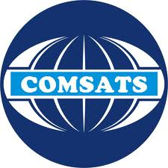  COMSATS Institute of  Information Technology |  | Muhammad Bilal  Address.: House#CB-133 mohalla banni near gulistan colony taxila  Tel no.:  Cell no.: 0313-5037067  Email: awan.bilal091@gmail.com |  | 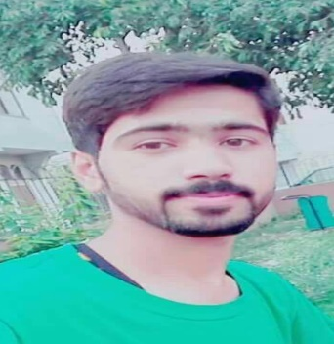
ACADEMIC QUALIFICATION
2018 | BS Electrical Engineering  Specialization: Computer  COMSATS Institute of Information Technology  Wah campus
 | CGPA | 2.27 | Upto 7th Semester
2014 | HSSC (FBISE)  Subjects: Physics, Maths, Chemistry  Sir Syed College Wah Cantt
 | Marks | 672/1100 | Grade |  | B
2012 | Matric (FBISE)  Subjects: Physics, Maths, Chemistry, Biology  F.G.Boys High school Wah Cantt
 | Marks | 694/1050 | Grade |  | B
TECHNICAL EXPERIENCE/WORK EXPERIENCE
- Internee at PTCL from 24/07/2017 to 01/09/2017
FINAL YEAR PROJECT
Cooling of Microprocessor.
SEMESTER PROJECTS
- Obstacle avoidance robot
- Home automation and security
- Control the speed of DC motor using PID controller
- Food detector using Arduino UNO
- Door alarm system using LDR
- High pass filter using MATLAB
- Implementation of SAP on FPGA SPARTEN 3E
- BCD to excess-3 code converter using logic gates
- Analog to digital converter 8-bit
TECHNICAL SKILLS
- Strong troubleshooting and problem-solving skills
- Calibration and troubleshooting of different type of sensors and their indicators.
- PCB Designing
- Electronic Circuit Analysis/Simulation
- MATLAB
- TRiLOGI
- Proteus
- Arduino
- Xilinx
- Cadence Virtuso
- Project Management
ACHIEVEMENTS/EXTRA CURRICULAR ACTIVITIES
- Technical training at PTCL
- Attending IEEE Seminars and participation
- Participation in International Conference on Frontiers of Information Technology
- Participant of All Pakistan Electrical Symposium 2017

