Application Letter
To
HR director,

………………………………Rawalpindi region………….
Dear Sir!
I am interested to join …as Lecturer Electrical/Electronic department...........
I am confident that my qualification, skills and past working experiences are relevant to the requirements of any post of electronic/electrical/Physics. My experiences in academic and engineering, is good enough, my research works have given me an edge to easily adapt a new working environment. If given the opportunity to extend my abilities in related field, I am certain that I can make significant contribution to uphold the goals of institute.
Should this application merit your favorable consideration, please contact me at this email address (sohaibfrazy@yahoo.com). Thank you for your time and consideration and look forward to hear from you.
Thank You.
Yours Sincerely,
Muhammad Sohaib Frazy
0092-345-5951759
sohaibfrazy@yahoo.com

Muhammad Sohaib Frazy
Postal:
Permanent: Dist. Gujarat Lalamusa , Camping Ground .House # 198.
Present: Rawalpindi, Dohk Kashmirian. DK-181
Cell # 0345-5951759
P.T.C.L # 051-4915558
Email: sohaibfrazy@yahoo.com
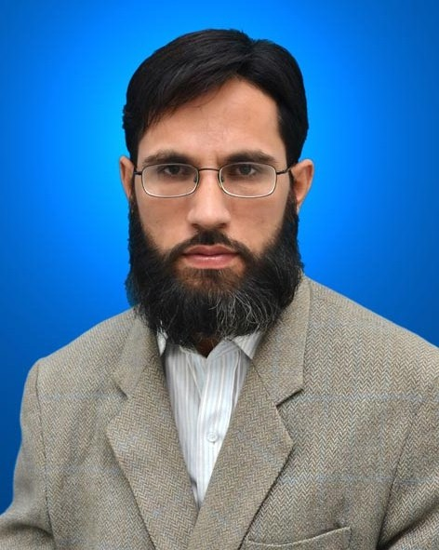
Figure 1

OBJECTIVE

To secure a position with a well established organization with a stable environment that will lead to a lasting relationship in the field of research in Electrical & Electronic and Science.
PERSONAL DATA

- NAME: Muhammad Sohaib
- FATHER’S NAME: Muhammad Fazal
- DATE OF BIRTH: 17-01-1984
- NATIONALITY: PAKISTANI
- RELIGION: Islam
- C.N.I.C. NO: 61101-7260082-1
- DOMICILE: Gujarat(Punjab)
QUALIFICATION

Sr# | Education | Years | Board\University | Specialty
01 | SSC | 2001 | Gujranwala board | Physics, Chem, Bio
02 | HSSC | 2003 | Gujranwala board | Physics, Math , Comp
03 | HifziQuran | 2005 | Naeemia Rizviya | Tajweed/Qirat
04 | BSc | 2007 | Punjab University .LHR | Physics , Math (A+B)
05 | BS(Hons) | 2012 | Sarhad University Peshawar. | Applied Physics  Electronic
06 | MS/Mphil | 2015 | Bahria University | EE-Power
Special Education

Course | Institute | Status
Robotic | University of Pennsylvania(US) | Clear
Computer Vision | Udacity (Online) | Continue
Matlab | Udacity (Online) | Clear
Embedded system | AGT (Rawalpindi) | Clear

Research Publications

- Review paper (Obstacles avoiding techniques in robotic applications)
- Application of Neural Network for Robotic Navigation by Avoiding Obstacles (International Journal of Intelligent Systems and Application in Engineering. 2018)
Science Project work for students

- Simulation, Designing, Hardware application of Industrial fire fighter robot.
- Simulation, Designing, Hardware application of Obstacle avoiding robot.
- Simulation, Designing, Hardware application of Line tracking robot.
- Simulation, Designing, Hardware application of Voice & Remote controlled robot.
- Simulation, Designing, Hardware application of University Students Projects.
- Simulation, Designing, Hardware application of Home appliances controlled by remote control.
- Simulation, Designing, Hardware application of wireless Quadcopter with self balancing system.
- Simulation, Designing, Hardware application of edge detector robot.
- Simulation, Designing, Hardware application of Flywheel Energy System.

Computer

- Computer Hardware one Month Course in Vocational Technical & Education Centre Rawalpindi. (Hardware).
- (MS Office, MS Word, MS Excel, MS Access, MS Power Point, Networking Internet HTML Notepad )

Teaching and Administration Experience

Name of post | Name of department | From | To
Teacher | Capital College of Science G9-Markaz | 2006 | 2007
Lecturer | IIST(Islamabad) | 2009 | 2017
Administrator | Boys Hostal-G9/4 | Aug-2010 | Feb-2017
Electronic Project supervisor | Bismillah Engineering (G9/4) | March 2012 | 2014
Lecturer (visiting faculty) | Alfaran institute of IT (RWP) | April 2017 | 2018
Lecturer (Private) | Comwave Islamabad | April 2016 | 2019

