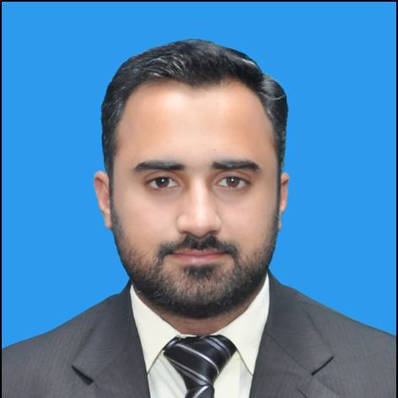
Address: 1-D, Public Health Staff Colony, 2-C-1
Tipu Chowk, Town Ship, Lahore.

Email: engr.asifali1@gmail.com

Contact: +92-344-4324830

ASIF ALI

Objective:

Seeking experience, knowledge and position among the professionals, so that in future I will have a challenging career in industry and do some valuable work for it with the best use of my capabilities.

EDUCATION:

2007–2011 BSC Electrical Engineering
University of Central Punjab, Lahore

2005-2007 FSC (pre-Engineering)
Punjab College of Science, Lahore

2003–2005 Matriculation (Science Subjects)
Quaid-e-Azam Public High School, Lahore

EXPERIENCE:

PUNJAB MASSTRANSIT AUTHORITY, LAHORE [MAY 2013 – ONGOING]

- Working as FIELD INSPECTOR in Punjab mass-transit authority Lahore.
- Details of the job are Inspection and assuring of services from vendors for smooth running of the project.
- Authority representative for Installation and maintenance assurance of 53 Generators, 100 escalators, electric control panels and other electrical equipment installed by Electrical contractors.
- Identify problems in the process and resolve them in quickly and timely manner.
- Supervise and assist all design documentation and drawings.
- Responsible for vendor quote evaluation, sub-contractor management and outsourcing.
- Monitoring and evaluating services of the vendors as per criteria.
- Authority’s representative for handing over – taking over of stations.
GLOBAL ENGINEERING SERVICES [OCT 2011 – SEP 2012]

- Worked as ASST PCB DESIGN ENGINEER in Global Engineering Services.
- Detail of the job was Layout of PCB design which includes fan-out all components pins, silkscreen adjustment of the board as per industry standards; add constraints and planes, route critical and miscellaneous signals according to constraints provided by costumer and GES standards.

INTERNSHIP:

TRANS FAB [AUG 2010 – SEP 2010]

- Worked in Quality Control department where some tests were performed on a transformer to assure the customer that product has no fault and ready to deliver. (Testing Lab).
- Worked in Production department where we did the design of transformer in which Windings and Core were designed and provided to the related section. After the making of windings and core it is sent to the assembly section where transformer is assembled with connections (Winding Section, Core Section, and Assembly Section).
- Was able to get some hands on experience with various types of electrical equipment’s.

TRAINING:

ZTE BSC training—Mobile communication course [NOV 2010 – JAN 2011]
- Took ZTE training on BSC given by ZTE qualified engineer
- Developed understanding of installation
- Did hands-on configuration of BSC and BTS systems

COMPUTER LITERACY & SKILLS:

Application Packages: MS Word, MS Excel, MS Power Point

PERSONAL ATTRIBUTES:

- Goal oriented with focus on deliverables.
- Ability to provide technical assistance and resolution.
- Able to work together with a team and individuals to solve and define the developmental problems.
- Excellent communication and organization skills.

