***ALI SALEEM Address:Lane-F,St#02,H#17,Ali Town, Tarlai Kallan, Islamabad.*** 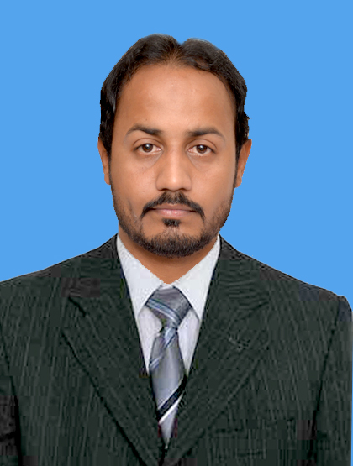

***Mobile No: 03315377352***

***Email******Address****:ali_rohtasi@hotmail.com*

***Personal Attribute***

***A self-motivated individual possessing excellent numeric, organizational and communication skills.Looking forward earning prestige and pride for the organization and myself.***

***Key Skills***

|  |  |
| --- | --- |
| ***o Maintain the Business confidentiality.***  ***o Good team player***  ***o Maintain good and professional relationship with customers and third parties.***  ***o Presentation and documentation skills***  ***o Maturity, honesty, ability to look at challenges as opportunities***  ***o Extreme dedication to work for positive outcome of the tasks undertaken*** | ***o Ability to successfully manage multiple priorities and assignments.***  ***o Energetic to meet deadlines.***  ***o Proficient in writing, reading and speaking English and Urdu.***  ***o Proficiency in computer aided management software.***  ***o Quick learner.***  ***o Proficient in Windows Operating System & Microsoft Office*** |
| ***Professional Experience***   * ***Dulsco(Abu Dhabi)2015-2016***   ***Store Keeper In Eithad Airway Cargo***   * ***Warid Telecom Franchise, Wazirabad, Pakistan***   ***Customer Service Officer(April,2013 to May,2016)***  *My outline of responsibilities was as below:*   * *Responsible for Dealing Customers Regarding their Network Problems.* * *Coordination with Head Office and on matters related to Operations,* * *Treasury, Finance and Administration.* * ***British Council, Islamabad, Pakistan***   ***Supervisor (March, 2010 to March,2013)***  *My outline of responsibilities was as below:*   * *I have good knowledge and experience of Supervision In* ***British Council,*** *Islamabad.* * *I worked in Examination Department Of* ***Cambridge University.*** * *Taking papers of* ***A O Levels/ ACCA/IELTS/NEBOSH.*** * *Planning for Taking papers, their all arrangement their venues.* * ***Oil & Gas Exploration Company Cracow Ltd, Karachi, Pakistan***   ***Supervisor (April 2005 to August2008)***  *Current duties and responsibility were as under:*   * *Striving to achieve the Multi-dimensional Business growth targets assigned by branch management through sales maximization by introducing new and existing relationships.* * *Supervision ofall staff including housekeeping staff their problems & Also assign their duties.* * *Staff Management to engage them in a team work.* * ***New Orchard Guest House, Islamabad Pakistan***   ***Supervisor (June 2007 to June2008)***  *Performed following functions and duties:*   * *Striving to achieve the Multi-dimensional Guest House growth & Their Good Will or targets assigned by management through maximization by introducing new and existing relationships.* * *Supervision of all staff including housekeeping staff their problems & Also assign their duties.* * *Staff Management to engage them in a team work*. * ***Standard Chartered Bank, Islamabad ,Pakistan****.*   ***DSR(January 2007 to September 2007)***  *Main responsibilities were as under:*   * *Worked In Consumer department of credit cards.* * *Preparation of Periodic accounts statement of card holders as per given guidelines.* * *Implemented new accounts of customers procedures and processes.* * *Coordination with other banks.* * *Verifications of new credit card holders.* | | |  |

* ***Suzuki Motors, Islamabad Pakistan****.*

***Accountant (January 2002 to April 2002)***

*Major performed responsibilities were as given below:*

* *Maintaining basic accounts, book keeping, maintaining basic accounts, book keeping.*
* *Managing and reconciliation of bank accounts of firm.*
* *General Office Administration.*
* *Promotional Activities & Campaign Of* ***Suzuki Motors.***
* *Making arrangements for the receivables of the firms*

***Education***

|  |  |
| --- | --- |
|  | ***E.MBA(HR)(2009-2010)***  ***(National Institute Of Management Sciences, Faisalabad)***  ***Bachelors Of Commerce(B.COM)(2002-2005)***  ***(Allama -qbal University, Islamabad, Pakistan)*** |
| ***Academic*** | ***Intermediate of Commerce(I.COM) (1998-2000)***  ***(Punjab College Of Commerce, Islamabad, Pakistan)***  ***Matric (Science)(1996-1998)***  ***(Federal Board, Islamabad, Pakistan)*** |

***Trainings***

* ***IT Traning*** *from* ***Johar Institute of Information Technology(September 2006)***
* ***Air Ticketing Course*** *from* ***Tourisim Development Corporation Rawalpindi(June 2005-July2005)***
* ***Various Saftey/Child Protection Trainings*** *Every Years from* ***British council(2009-2014)***
* ***APTIS Test*** *From* ***British Council (2013)***
* ***Worked in Hajj Operation in Traffic Department(2009-2010)***

***Personal Information***

***Date of Birth: 17-March-1982***

***CNIC: 61101-1948939-7***

***Domicile: Punjab(Jhelum)***

***Religion: Islam***

***Driving License:Valid Islamabad(LTV)***

***Visa Status: Visited 4Months Dubai ,1 Month Saudia &Qatar***

***Communication***

***English/Urdu/Punjabi***

*I have also developed my communication skills during my work experience by liaising with management, attending meetings, and providing feedback and conversing with different departments via email and telephone. Other than English I am also fluent in Urdu, and Punjabi.*

***Other Certification & Skills***

***Microsoft Word/Excel/PowerPoint***

*I am competent in using Microsoft packages such as PowerPoint, Excel, Word& On Internet Work*

***References****: References will be furnished upon request.*