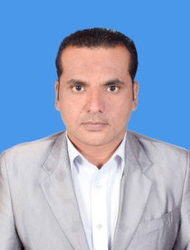

* Excellent Communication skills

{English, Urdu}

* Territory Manager Joined 14/06/2016 Tabros Pharmaceuticals Pvt LTD Karachi Pakistan

**Address:**

**Moh: Naqshbandi, Kundian**

**District: Mianwali.**

**Cell**: 0336-1055150

**Email**: mr.thesaurus10@gmail.com

**TARIQ NAVEED AKHTAR**

Seeking a position in the field of Pharmaceutical as represantive that build my abilities. I want to work in competitive environment. To compete the challenges in the organization with confidence skills, Abilities proficiency and hard work to achieve the position of professional satisfaction

**Objective**

**Language**

**Experience**

* **Matriculation** in 2008 with **2nd** division from Board of Intermediate & Secondary Education, Sargodha.
* **Intermediate** in 2011-12 with **2nd** division from Board of Intermediate & Secondary Education, Sargodha.
* **Graduation** in 2015 with **2nd** division from University Of Sargodha.

**Academic Records**

Father`s Name Aziz Ullah Akhtar

Date of Birth 05-10-1989

Domicile (Dist) Mianwali (Punjab)

CNIC # 38303-0576921-5

**Personal Information**